
FACULTY OF ENGINEERING AND TECHNOLOGY
DEPARTMENT OF WATER RESOURCES ENGINEERING
GROUP 14 WAR
S/N | NAMES | REG.NO
 | KALISA RONALD | BU/UP/2025/1540
 | ACHOLA ELIZABETH | BU/UP/2025/3247
 | OLARA EMMANUEL GEORGE | BU/UP/2025/2136
 | MPUUGA MARK | BU/UP/2025/3268

SOLUTION OF x³ − 5x + 3 = 0
Secant Method, Newton–Raphson Method and Runge–Kutta Method
Including FOR and WHILE loop pseudocode and flowcharts
Task;
Get the math questions solved in secant, runge-kutta, and newton Raphson
Get solutions for ‘for’ and ‘while’ loop for each of the equations. Draw flowchart and get pseudo code

1. Problem statement
Solve the nonlinear equation
f(x) = x³ − 5x + 3 = 0
The equation has three real roots.
The following starting values are used: x₀ = 0, x₁ = 1 for the Secant method; x₀ = 1 for Newton–Raphson; and x₀ = 1 with h = 0.1 for the Runge–Kutta IV method after rewriting the root problem as the initial-value problem y′ = f(y), y (0) =1.

2. Secant Method
Formula:
xₙ₊₁ = xₙ − f(xₙ) (xₙ − xₙ₋₁) / [f(xₙ) − f(xₙ₋₁)]
Using x₀ = 0 and x₁ = 1 gives convergence to the root x ≈ 0.656620431.
Iteration table:
N | xₙ₋₁ | xₙ | xₙ₊₁ | f(xₙ₊₁) | |Δx|
1 | 0 | 1 | 0.750000000 | -0.328125000 | 0.250000000
2 | 1 | 0.750000000 | 0.627906977 | 0.108028224 | 0.122093023
3 | 0.750000000 | 0.627906977 | 0.658147479 | -0.005655480 | 0.030240502
4 | 0.627906977 | 0.658147479 | 0.656643089 | -0.000083983 | 0.001504389
5 | 0.658147479 | 0.656643089 | 0.656620413 | 0.000000068 | 0.000022677
6 | 0.656643089 | 0.656620413 | 0.656620431 | -0.000000000 | 0.000000018
Result: x ≈ 0.656620431
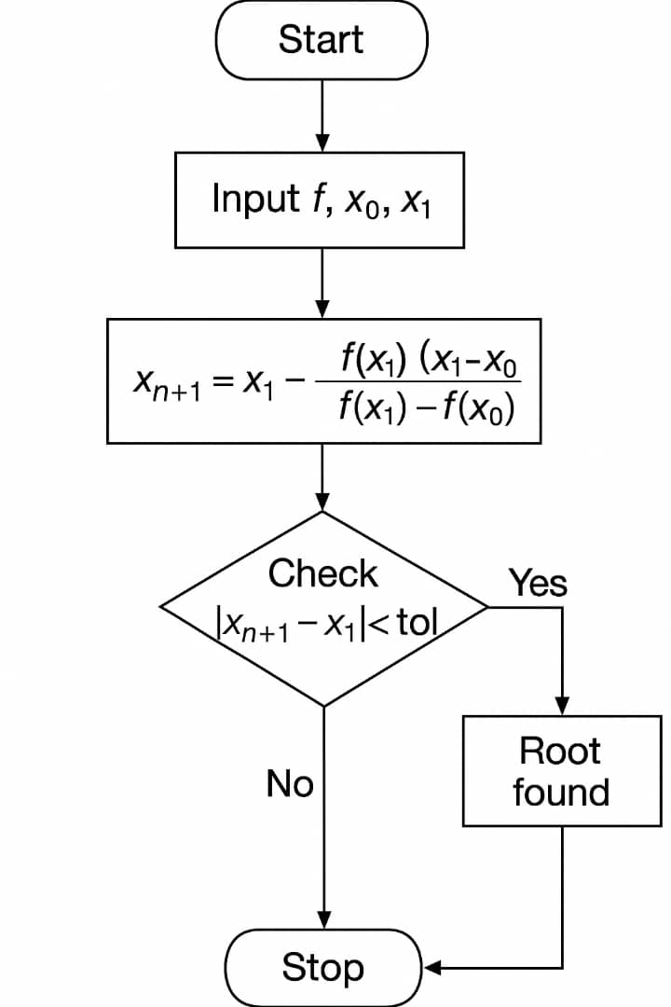

2.1. Secant Method — FOR loop pseudocode
START
x0 = 0, x1 = 1;
tolerance = 1.0000e-06
for n = 1: 50
f0 = x0^3 - 5*x0 + 3
f1 = x1^3 - 5*x1 + 3
x2 = x1 - f1*(x1-x0)/(f1-f0)
if abs(x2-x1) < tolerance
break
end
x0 = x1
x1 = x2
end
fprintf ('Root = %.9f\n', x2);
END

2.2. Secant Method — WHILE loop pseudocode
START
x0 = 0;
x1 = 1;
tolerance = 1.0000e-06;
n = 0
while n < 50
f0 = x0^3 - 5*x0 + 3
f1 = x1^3 - 5*x1 + 3
x2 = x1 - f1*(x1-x0)/(f1-f0)
n = n + 1
if abs(x2-x1) < tolerance
break
end
x0 = x1
x1 = x2
end
fprintf ('Root = %.9f\n', x2);
END

3. Newton–Raphson Method
f′(x) = 3x² − 5
Formula: xₙ₊₁ = xₙ − f(xₙ)/f′(xₙ)
N | xₙ | xₙ₊₁ | f(xₙ₊₁) | |Δx|
0 | 1 | 0.500000000 | 0.625000000 | 0.500000000
1 | 0.500000000 | 0.647058824 | 0.035619784 | 0.147058824
2 | 0.647058824 | 0.656572795 | 0.000176568 | 0.009513972
3 | 0.656572795 | 0.656620430 | 0.000000004 | 0.000047634
4 | 0.656620430 | 0.656620431 | 0.000000000 | 0.000000001
Result: x ≈ 0.656620431
Newton’s Raphson Method

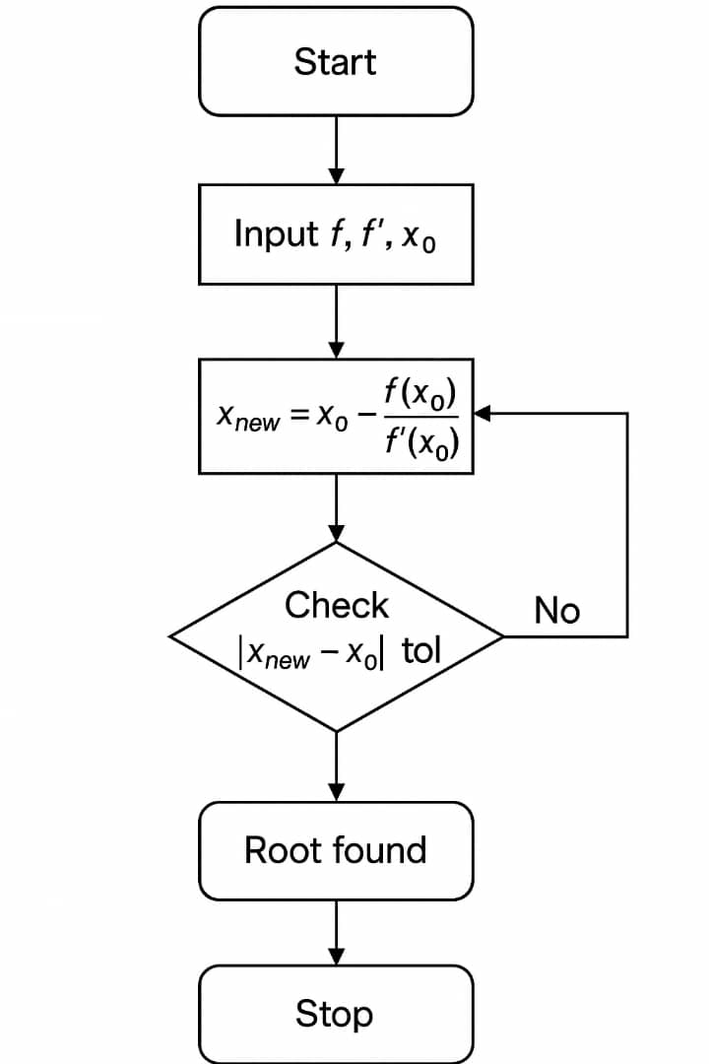
3.1. Newton–Raphson — FOR loop pseudocode
start
x = 1;
tolerance = 1.0000e-06
for n = 1: 50
fx = x^3 - 5*x + 3
dfx = 3*x^2 - 5
xnew = x - fx/dfx
if abs(xnew-x) < tolerance
break
end
x = xnew
end
fprintf ('Root = %.9f\n', xnew)
stop
3.2. Newton–Raphson — WHILE loop pseudocode
START
x = 1;
tolerance = 1.0000e-06;
n = 0;
while n < 50
fx = x^3 - 5*x + 3
dfx = 3*x^2 - 5
xnew = x - fx/dfx
n = n + 1
if abs(xnew-x) < tolerance
break
end
x = xnew
end
fprintf ('Root = %.9f\n', xnew);
END

4. Runge–Kutta 4th Order (RK4)
RK4 is an ODE solver rather than a conventional root-finding method. For the requested equation, we can use the auxiliary IVP y′ = y³ − 5y + 3, y (0) =1 and demonstrate the RK4 algorithm. This does not by itself define a root of the original equation; the equilibrium values of the IVP satisfy y³ − 5y + 3 = 0.
For y′ = F(y), the RK4 steps are:
k1 = F(yₙ)
k2 = F (yₙ + h k1/2)
k3 = F (yₙ + h k2/2)
k4 = F (yₙ + h k3)
yₙ₊₁ = yₙ + (h/6) (k1 + 2k2 + 2k3 + k4)
Use h = 0.1 and y₀ = 1. The RK4 iteration can be repeated with a FOR or WHILE loop.
3. Flow chart
START
Input y0, h, N, n = 0

Calculate k1. k1 = f(y)

Calculate new y y = y+h/6(k1+2k2+2k3+k4)

Calculate k2. k2 = f(y+hk1/2)

Calculate k3. k3 = f(y+hk2/2)

Calculate k4. k4 = f(y+k3)

n = n + 1

No
Is n < N?

Yes
print y
END

4.1. RK4 — FOR loop pseudocode
START
y = 1, h = 0.1, N = 10
for n = 1 : N
k1 = y^3 - 5*y + 3
k2 = (y + h*k1/2) ^3 - 5*(y + h*k1/2) + 3
k3 = (y + h*k2/2) ^3 - 5*(y + h*k2/2) + 3
k4 = (y + h*k3) ^3 - 5*(y + h*k3) + 3
y = y + (h/6) *(k1 + 2*k2 + 2*k3 + k4)
fprintf('n = %d, y = %.6f\n', n, y);
END

4.2. RK4 — WHILE loop pseudocode
START
y = 1;
h = 0.1;
n = 0;
N = 10
while n < N
k1 = y^3 - 5*y + 3
k2 = (y + h*k1/2) ^3 - 5*(y + h*k1/2) + 3
k3 = (y + h*k2/2) ^3 - 5*(y + h*k2/2) + 3
k4 = (y + h*k3) ^3 - 5*(y + h*k3) + 3
y = y + (h/6) *(k1 + 2*k2 + 2*k3 + k4)
n = n + 1
fprintf('n = %d, y = %.6f\n', n, y);
end
END

Summary of results
For x³ − 5x + 3 = 0, the three real roots are approximately:
- -2.490864
- 0.656620
- 1.834243

